Chapter 16
WHAT WERE THE 1960s LIKE IN OKLAHOMA?

I. DEFINE. Write a short definition for each word below.
1. Prohibition __________________________________________________________________
2. stalemate____________________________________________________________________
3. repealed ____________________________________________________________________
4. reapportionment_______________________________________________________________

II. COMPLETION. Fill in the paragraphs correctly.

1) The youngest elected governor of Oklahoma was ________________________________.
2) During his term, a repeal of prohibition became the 27th Amendment to the state’s _____________________. 3) Also during his term, a federal court ordered ________________________ to equalize state voting.
4) Edmondson resigned to take over for ________________________, so 5) Lieutenant Governor ________________________ finished Edmondson’s term.
6) The state’s first Republican governor was __________________________, inaugurated in _______. 7) The most controversial issue during Bellmon’s first administration was ______________. 8) For example, ____________________ and teenagers protested with sit-ins in Oklahoma City. 9) Henry Bellmon was succeeded as governor by _____________________, who took office in 1967. 10) The next governor was ________________________, who took office in 1971.

III. FILL IN THE BLANKS AND MATCH TOPICS.
1) Mike Monroney served as a U.S. __________________ and as a U.S. 2)__________________. The F.A.A. named an aeronautical center after him because of his help to the 3) ______________ industry.
4) A man from McAlester, ________________________, achieved the highest political office of any Oklahoman. That office was 5)_______________________________________________________.
6) and 7) In the space below, name these governors (two photos) and the years they served:
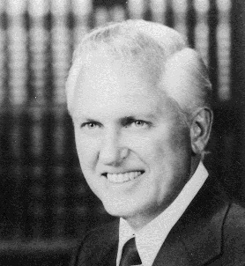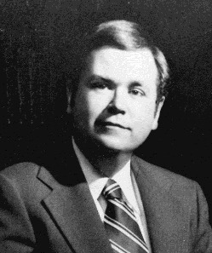
Now draw lines from the photos to the subjects that relate to each of these two governors.
McAlester Prison Riot
Indicted for extortion and bribery
Tax reduction and tax reform
Resigned a few days early to become a U.S. Senator
IV. SEQUENCE. Draw a horizontal timeline for 1958 to 1962. Use the letters to mark events on your timeline.

A Edmondson was sworn into office as governor.
B Republicans and Democrats were involved in a near-riot in Oklahoma City.
C Prohibition was repealed in Oklahoma.
D Henry Bellmon was inaugurated.
E Oklahoma City became the largest city in land area in the U.S.
F Civil rights protests began in Oklahoma City.
G Stores began to sell liquor legally.
H The first Republican governor of Oklahoma was elected to office.
(Make your timeline in this space.)

1958 1959 1960 1961 1962

V. WRITING ASSIGNMENT.

Imagine that you are a teacher telling students to write papers and you will tell them which sources are worth using. Pick one of these people to study: Patience Latting, J. Howard Edmondson, or Henry Bellmon. Then find three Internet sources that students could use to write a 10-page paper about the person.

Your assignment is to write a description of each of these digital sources, naming their strengths and weaknesses. Write one to three paragraphs about the usefulness of the sources. You may include evidence such as quotes or an outline from the source, with proper credit.

______________________________________________________________________________________________________________________________________________________________________________________________________________________________________________________________________________________________________________________________________________________________________________________________________________________________________________________________________________________________________________________________________________________________________________________________________________________________________________________________________________________________________________________________________________________________________________________________________________________________________________________________________________________________________________________________________________________________________________________________________________________________________________________________________________________________________________________

