Chapter 7 WHAT TRIBES COMPRISED THE “WESTERN” INDIANS?

I. DEFINE VOCABULARY. Write a short definition of each word as used in this chapter.

1. reservation _____________________________ 6. destitute _______________________________
2. Old Northwest __________________________ 7. shackled_______________________________

3. latitude _______________________________ 8. retaliated ______________________________
4. bombard ______________________________ 9. exile _________________________________

5. massacre ______________________________ 10. marauding____________________________
II. MAP. Identify the areas of Indian Territory 1866-1889. Print names where you can fit them. Use numbers in smaller spaces.

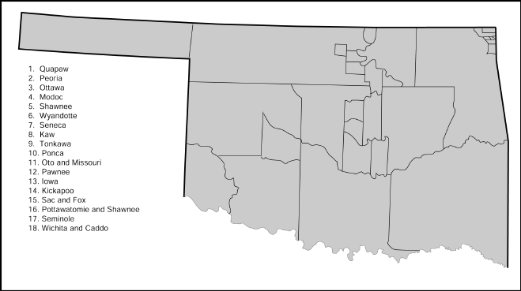

III. IDENTIFY DATES AND EVENTS. Give the year when each of the following events occurred.

______ 1. Sandusky Senecas, Mixed Senecas, and Shawnees arrived in Indian Territory to find their assigned land belonging to someone else.
______2. The Quapaws were moved and settled on the wrong land.
______3. The Quapaws had to move again.
______4. The Nez Percé signed a treaty in which the government promised them perpetual tenure of
their lands.
_____ 5. The Sac and Fox tribe was moved to Indian Territory.
______ 6. The Nez Percé were moved to Indian Territory.
***********
______ 7. The Sand Creek Massacre occurred.
______ 8. The Medicine Lodge Creek Treaty was signed.
______ 9. The Battle of the Washita occurred.
______ 10. The government declared that it would no longer deal with Indian tribes through treaties.

IV. COMPLETE THESE SENTENCES.

1. The Sandusky Senecas were remnants of the original____________________________________.
2. The Stokes Commission was appointed by President ____________________________________.
3. _____________________, Chief of the Modocs, moved his tribe back to its homeland
without government permission.
4. Chief_____________________ led the Nez Percé in a futile attempt to escape to Canada.
5. ____________________made several trips to Washington to plead for the return of his people to the Northwest.
6. At Medicine Creek, government commissioners had instructions to:
(1) ____________________________________________________________________________
(2) _____________________________________________________________________________
and (3) _____________________________________________________________________________
7. The leader of the troops at the Sand Creek Massacre was ________________________________.
8. The leader of the troops at the Battle of the Washita was __________________________.
9. The leader of the Southern Cheyennes at Sand Creek and the Washita was______________________.
10. The Wichitas, Caddoes, and Delawares, with four other tribes, were settled in the
____________________________ District.

V. WRITING ASSIGNMENT.
Research how the native peoples resisted removals and the reservation system. You may focus on one tribe or give an overview of several tribes. Look for print or electronic sources of information and cite (name) the source(s). Start your notes on these lines. Allow time to plan, draft, and revise a report of two or three paragraphs. If time allows, format your short report as a PowerPoint with photos and include links to your sources.
____________________________________________________________________________________________________________________________________________________________________________________________________________________________________________________________________________________________________________________________________________________________________________________________________________________________________________________________________________________________________________________________________________________________________________________________________________________________________________________________________________________________________________________________________________________________________________________________________________________________________________________________________________________________________________________________________________________________________________________________________________________________

