Chapter 5 WHAT HAPPENED TO
CHEROKEES, SEMINOLES, AND WESTERN TRIBES DURING REMOVALS?

I. DEFINE VOCABULARY. Write a short definition of each word below, as it is used in the textbook.
1. evict____________________________________________________________
2. forge (verb) ______________________________________________________
3. formidable_______________________________________________________
4. census__________________________________________________________
5. alliance__________________________________________________________

II. COMPLETE THE SENTENCES. Fill in the word or words that complete each statement best.

1. The signers of the Treaty of New Echota were agreeing to _______________________________________.
2. The principal chief of the Cherokees who opposed removal was___________________________________.
3. The tribe that gave the name “Trail of Tears” to the removals was the _____________________________.
4. When Eastern Cherokees moved west in the 1830s, they called the Western Cherokees _________________. 5. The general who commanded the removal of the Cherokees was ________________________________.

III. MATCH DATES TO EVENTS. One date should be used twice.
____ 1.Minor Cherokee leaders signed the first treaty that referred to their removal.
____ 2. Cherokees were removed during the Trail of Tears.
____ 3. In Indian Territory, Cherokees united as one nation. A. 1838-1839 winter
____ 4. Seminoles signed the Treaty of Camp Moultrie. B. 1817
____ 5. The Mexican War brought more whites to Indian lands. C. 1846
____ 6. Osceola led the beginning of the Great Seminole War. D. 1819
____ 7. The U.S. abandoned efforts to drive out the last Seminoles. E. 1823
____ 8. Spain ceded (gave up) Florida to the United States. F. 1835
G. 1859

IV. COMPLETE. Fill in the blanks to complete the statements correctly.
1) The Seminoles lived in the present state of _____________________________. 2) They were tricked or bribed into moving south of Tampa Bay in swampland we call the ___________________________. 3) The land was not suitable for ____________________. 4) The Seminoles had to violate the boundaries of the treaty because they were _______________ and because 5) white people came into the Seminole villages looking for ______________________________.
(continues on next page)

6) The Treaty of Fort Gibson contained an agreement that the Seminoles would move west as part of the
____________________ Nation. 7) Though not a chief, the most powerful leader of the Seminoles during the Great Seminole War was ____________________. 8) After he died in prison, the leader of the Seminoles was __________________. 9) By 1844, there were only about __________ Seminoles in the Territory. 10) During the Seminole Removals, more than ___________per cent of their number died.
11) The most lawless area of the region of Indian Territory was called ________________________.
12) The two events that encouraged whites to move west were the ____________________ and the _______________________. Soon after the removals, the nation was facing the Civil War.

V. MAP. First mark the routes of the Chickasaw and Cherokee removals from the Southeast to their lands in Indian Territory. You will need the maps in the textbook, Chapter 4. Then use the map for Seminole removal routes, in Chapter 5, and add that route to this map.

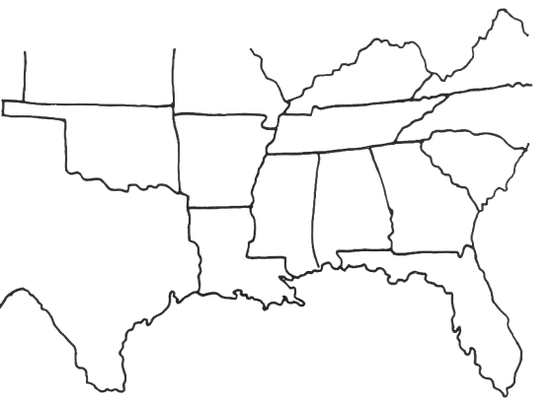
Key

Chickasaw

Cherokee

Seminole

VI. WRITING ASSIGNMENT.
Pretend you are living in Georgia in 1838. You have witnessed the mistreatment of the Cherokees. Write a factually persuasive letter to a newspaper editor. Describe what has happened and make suggestions for actual solutions. Be sure to state your position as your main idea and include evidence.

____________________________________________________________________________________________________________________________________________________________________________________________________________________________________________________________________________________________________________________________________________________________________________________________________________________________________________________________________________________________________________________________________________________________________________________________________________________________________________________________________________________________

