Chapter 2 WHAT HAPPENED WHEN EXPLORERS DISCOVERED THE NEW WORLD?

I. DEFINE VOCABULARY. Give a short definition of each word below as it is used in the textbook.

1. remuneration ___________________________ 6. stockade _______________________________

2. compensation __________________________ 7. “Northern Mexico” ______________________

3. imperialism ____________________________ 8. allies __________________________________

4. tributary ______________________________ 9. subsistence _____________________________

5. relinquish ______________________________ 10. surveyed _______________________________

II. MAPS. On this map, trace the routes of the European explorers.
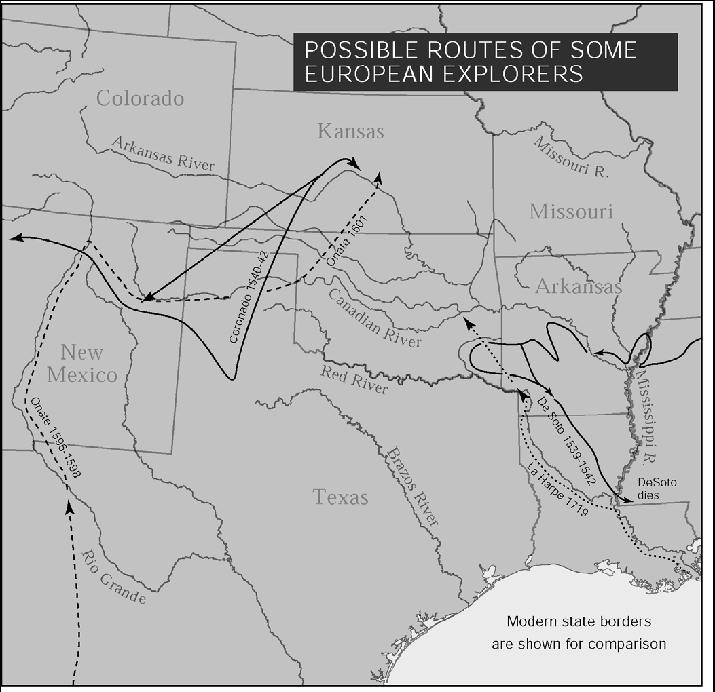

On the next map, color-code the expeditions of American explorers. You will need separate colors for Pike, Long, and Wilkinson. Follow the map in your textbook about American explorers.

III. MATCHING. Match the correct date for each event described below. Use two dates twice.
_____ 1. The Glenn-Fowler Expedition opened trade with the Western Tribes. A. 1682
_____ 2. Louisiana came under Spanish rule. B. 1763
_____ 3. George Sibley discovered the Great Salt Plains. C. 1819
_____ 4. Louisiana was purchased by the United States. D. 1803
_____ 5. The Adams-Onis Treaty was signed. E. 1806
_____ 6. LaSalle claimed Oklahoma for France. F. 1811
_____ 7. Wilkinson and Pike Expedition set out to explore Louisiana, G. 1817
including Oklahoma. H. 1821
_____ 8. Major Stephen H. Long built Fort Smith, the first fort in the area.
_____ 9. U.S. divided Missouri Territory and created Arkansas Territory.
_____ 10. Chouteau set up a trading post near Salina in the Three Forks area.

IV. COMPLETE. Write the word or words in the blanks that best complete each statement.
1. Western tribes exchanged _________________ with explorers for various other items.
2. Frontier forts created a _____________ of defense.
3. In 1800, Americans worried that the French would close the port of __________________.
4. The ruler of France who sold Louisiana to the United States was ____________________.
5. The Pike-Wilkinson Expedition was to follow the __________________ River to its source.
6. The French and Indian Wars lasted for ________ years.
7. __________________ led an expedition to the edge of Oklahoma where he was
turned back by Spanish soldiers.
8. On his second expedition, Major Long sent _____________________ to explore the
Arkansas River.
9. A _____________________ is land owned by the government that is not yet a state.
10. Ft. Smith was located near the mouth of the ______________________ River.
11. The first fort in the West was Fort ________________.
12. ____________________’s expedition was instrumental in opening trade with Western tribes.
13. Colonel Glenn’s trading post was located at ______________________________.
14. Osage chiefs showed the Great Salt Plains to _____________________________.
15. _______________ Lewis and _______________ Clark explored the Louisiana Territory.
16. ________________________ protested the sale of Louisiana to the United States.
17. The first American governor of the Louisiana Territory was___________________________.
18. As the territories divided and changed, the area now known as Oklahoma was included in the
territories of ________________, ______________, and ________________. (continued)

19. Spain gave up all claims to Florida and Oregon as a result of the _______________________Treaty.
20. As a result of that treaty, the United States gave up claims to _____________________.
21. The first roads were constructed to connect the ________________________________.
V. MATCHING. Match the name to the description.
A. Washington Irving 1. First settlers in Oklahoma 1. ___
B. William Henry Harrison 2. Member of a famous trading family 2. ___
C. William Clark 3. Governor of Indiana Territory and later President 3. ___
D. Auguste Chouteau 4. A famous literary visitor to the “log palace” 4. ___
E. traders 5. A famous explorer who governed Missouri Territory 5. ___

VI. MAP. On the map of the United States below, outline the Louisiana Purchase and the area affected by the Adams-Onis boundary. Use color-coding, if needed.

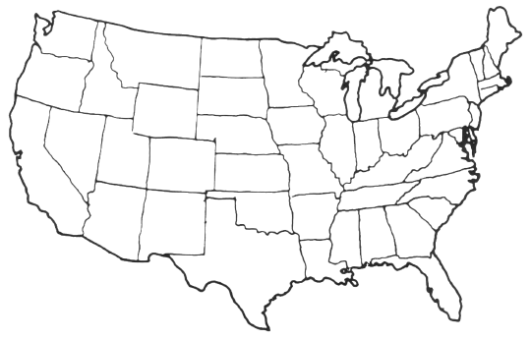

VII. WRITING ASSIGNMENT.
Write a paragraph about the Adams-Onis Treaty. Answer these questions: Who (which countries) were involved? What did it do? When did it happen, and why? If you quote directly from the text, use quotation marks.
______________________________________________________________________________________________________________________________________________________________________________________________________________________________________________________________________________________________________________________________________________________________________________________________________________________________________________________________________________________________________________________________________________________________________________________________________________________________________________________________________________________________________________________________________________________________________________________________________________________________________________________________________________________________________________________________________________________________________________________________________________________________

