Chapter 1
HOW DID AMERICAN INDIANS GET TO THE “NEW” WORLD?

I. DEFINE VOCABULARY. Give a short definition for each word, according to how the word is used in Chapter 1 or the Glossary.
1. papyrus ____________________________________ 6. runes ___________________________________

2. migration __________________________________ 7. viceroy_________________________________

3. Cross Timbers ______________________________ 8. established______________________________

4. archeologist________________________________ 9. memoirs _______________________________

5. artifact_____________________________________ 10. gypsum ________________________________

II. MATCH. Match the correct date to the event.

A. 1012 B.1718 C. 8000 B.C. D. 1300
E. 1682 F.1540 G. 1601 H. 1700s

____ 1. Folsom man lived in Western Oklahoma.

____ 2. Spiro mound culture existed in Eastern Oklahoma.

____ 3. Conquistadors crossed Oklahoma for the first time.

_____ 4. Onate led the last major Spanish expedition into Oklahoma.

_____ 5. Germans tried to colonize Eastern Oklahoma for the French.

_____ 6. Vikings may have made the rune stones near Heavener.

_____ 7. A French trader traded along the Red and the Arkansas rivers.

_____ 8. Oklahoma was claimed for France.

III. COMPLETE. Fill in each blank with a word or number that best completes each statement.

1. Indian legends about Indian origins were stories about _____________________________________.

2. We call the land bridge between Siberia and Alaska ____________________________________.

3. Scholars of Indian history have divided Indians into classifications according to differences in

__________________, _________________, and _____________________________________.

4. The land area now called Oklahoma measures __________________________________ square miles.

5. The land area is divided geographically by the (two words) ___________________________________.

6. The three main crops planted by Indians were _____________, ______________, and ______________.

7. Together, the main crops or staples are called the (3 words) _________________________________.

8. The most important item for trade in ancient Oklahoma was _______________________.

9. The only records of the early dwellers are the _________________________ and

______________________ uncovered in archeological digs.

IV. On the following chart, compare the lifestyles of the Folsom people, the Clovis people, and the Spiro people according to the column headings. Make notes, not sentences.

FOLSOM CLOVIS SPIRO

Housing

Food

Communities

Commerce

Social Programs

V. COMPLETE. Fill in each blank with the word that completes the sentence correctly.

1. In 1970, a Norwegian named ____________________________ sailed to North America in a papyrus boat.

2. He may have proved that ancient people could have come to North America from ____________________.

3. Life was much more difficult for people who lived in the ___________________________half of the state.

4. Most scientists believe that the first Indians came during the ________________________________age.

5. People who lived in Oklahoma 12,000 years ago were the _______________________________people.

6. People who lived in Oklahoma 10,000 years ago were the _______________________________people.
continued on next page

7. An early archeological discovery in Oklahoma is the __________________________mammoth kill site.

8. Items used by ancient societies which tell archeologists about these people are called ___________________.

9. Evidence of an advanced ancient tribe was found at _________________________ Mound.

10. The mass of forest and thickets dividing the state was the _____________________________________.

VI. On the following map identify the major geographic areas and the possible migration routes from Beringia.

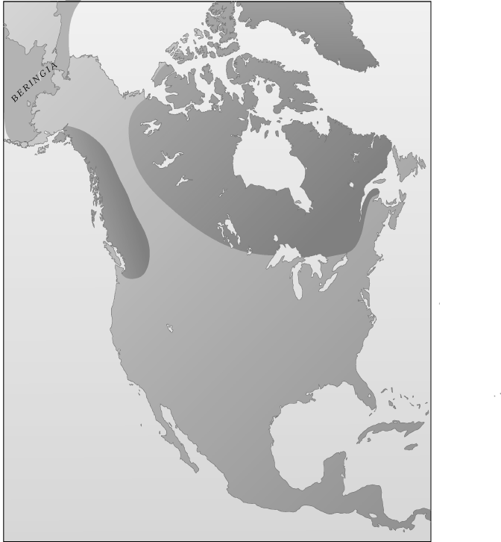

VII. MATCH. Match the description to the correct name.

_____ 1. Padilla A. first white explorer to cross Oklahoma
_____ 2. LaHarpe B. explorer sent to conquer Florida
_____ 3. Onate C. “the good viceroy”
_____ 4. Quivira D. captured Montezuma
_____ 5. LaSalle E. leader of the last major Spanish expedition into Oklahoma
_____ 6. Ranjel F. a Spanish chaplain who wanted to establish a mission for the tattooed people
_____ 7. Coronado G. DeSoto’s private secretary
_____ 8. Mendoza H. the tattooed people
_____ 9. DeSoto I. a French trader who traded along the Arkansas and Red Rivers
_____ 10. Cortez J. never saw Oklahoma but claimed the area for France

VIII. COMPLETE. Write the word or words in the blanks that complete the statement best.

1. The most important contribution (or influence) of the Spaniards to the Indians was ________________.

2. DeSoto’s expedition started in _____________ and moved westward.

3. The French expeditions were primarily interested in ________________and ________________.

4. The Indians could not advance in technology because they had no knowledge of the _____________.

5. (TRUE or FALSE): It is ___________that the Spaniards found each tribe had its own government.

IX. SOLVE PROBLEMS. In working this activity, use problem-solving skills to make your decisions: identify the problem, gather information, analyze the problem, identify alternative solutions, select a solution, and reach tentative decisions.

You are a conquistador who will accompany Coronado on his exploration of the area that is now the southwestern United States. It is your responsibility to chart the way and to keep the expedition from getting lost. You will march through a rough, arid country for much of your journey and cannot take all your possessions with you. You must decide what you will take, so you have listed your possessions. Now you must rank them to determine what is most important to take. Put number “1” beside the article you think is most important. Continue to rank the items until you have written the number “20” in front of the item of least importance. Be prepared to defend your choices. (Answers will vary.)

_____compass _____trinkets for trade _____animal traps
_____guns _____lumber _____horse
_____star chart _____gold and silver _____blanket
_____water _____cooking utensils _____flag
_____spices _____food _____rope
_____canteen _____sextant _____ammunition
_____knife _____pieces of flint

X. WRITING ASSIGNMENT.
First, create a question about state history you will research. Look for information in your text using the Table of Contents or the Index. Then find a second source (such as another textbook, www.okhistory.org, or the Library of Congress site, www.loc.org). Last, write one paragraph comparing that source and your textbook. Your paragraph should have five complete sentences or more. It should tell the reader your research question as well as how well each source answers the question, which source is easier to use, more thorough, and so on.

______________________________________________________________________________________________________________________________________________________________________________________________________________________________________________________________________________________________________________________________________________________________________________________________________________________________________________________________________________________________________________________________________________________________________________________________________________________________________________________________________________________________________________________________________________________________________________________________________________________________________________________________________________________________________________________________________________________________________________________________________________________________________________________________________________________________________________________

