GLOBAL PATTERNS OF HUMAN MIGRATION
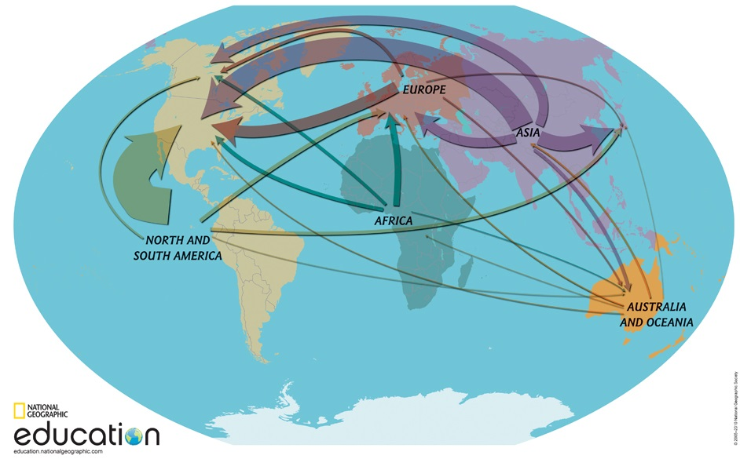
Directions:

STEP 1: Discuss the map of human migration around the world.
Examine the map above. Look at the current patterns of migration across the globe. The thickness of the arrows indicates amounts of people migrating: thicker arrows indicate major migration streams and thinner arrows indicated minor migration streams. The arrows reflect current migration patterns, not composition of populations.

Answer the following questions on a separate sheet of paper:
1. From which continent, or continents, are most people emigrating?
2. To which continent, or continents, are the most people immigrating?
3. What is one pattern of migration within North America?
4. Why do you think these patterns are happening?

STEP 2: Explore the data behind the map.
Required Materials:
Migration Data Table
Global Patterns of Human Migration Worksheet

Use the Migration Data Table to complete Part 1 of the Worksheet

STEP 3: Create a map of Targeted Human Migration Patterns.
Required Materials:
Global Patterns of Human Migration Worksheet
THE WORLD map handout
colored pencils

Complete Part 2 of the Worksheet.

