CULTURE
PRESENTATION NOTES
What is Culture?
-Culture is the way of life of a group people who share similar beliefs and customs.
A particular culture can be understood by looking at language, religion, daily life, history, art, government, and the economy.
Cultural Regions
The Earth is divided into culture regions. Each culture region includes countries that have certain traits in common. They may share similar economic systems, forms of government, and social groups. Their histories, religions, and art forms may share similar influences
Seven Elements of Culture
1. Social Organization
* Creates social structure by organizing its members into small units to meet basic
needs
* Family Patterns= Family is the most important unit of social organization.
Through the family, children learn how they are expected to act and what to
believe.
* Nuclear family= parents, children. This is a typical family in an industrial
society.
* Extended Family= several generations living in one household, working and
living together: grandparents, aunts, uncles, cousins. Respect for elders is
strong.
* Social classes=rank people in order of status, depending on what is important to the
culture (money, job, education, ancestry, etc.)
2. Language
* Language is a key element in a culture's development.
*Through language, people communicate ideas and experiences and pass on cultural
values and traditions.
*All cultures have a spoken language (even if there is no developed forms of writing).
*People who speak the same language often share the same culture.
*Some societies, however, include large groups of people who speak different
languages. India, for example, has more than 700 languages.
*Language Families=Large groups of languages having similar roots.
ex. Romance Languages(French, Italian, Spanish, Portuguese).
*Each language can have several different dialects.

3. Religion
*Religion helps people answer basic questions about the meaning and purpose of life.
It supports the values that a group of people consider important.
*Religious beliefs vary around the world.
*Atheism=the belief in no god or gods
*Monotheism=the belief in one god
*Polytheism=the belief in many gods
*Religious practices such as prayers and rituals vary from one culture to another.
Struggles over religious differences are a problem in many countries. These troubles
often find their roots in the past.
*In many cultures, however, religion enables people to find a sense of identity.

With more than 200 independent countries existing in the world today, it is important to understand
what characteristics defines a country
. 1. clearly defined territory
-the land, water, and natural resources within its boundaries.
2. population
-the people; the size of the population does not matter.
3. sovereignty
-freedom from outside control
4. government
-the institution through which a society makes and enforces its public policies and
provides for its common good.

4. Government
*Government is the institution through which a society makes and enforces its public
policies and provides for its common good.
*These needs include keeping order within a society, protecting the society from
outside threats, and providing some services to its people.
*Government Structure=the relationship between the central government and
smaller internal units of government
*Each government system or political system can be classified according to its structure
and its basis of authority.
*Unitary= one central government runs the nation.
Local governments have only the powers given them by the central
government.
*Federation: some powers are given to the national government while other
powers are reserved for more local governments.
*Confederation: smaller political units keep their sovereignty and give the
central government only very limited power.

*Government Authority=the source of a government's authority; where does it get it
power to govern.
*Authoritarian=: the leader(s) hold all or nearly all of the power.
*Dictatorship= ruler/ruling group holds power by force usually relying
on the military for support
*Totalitarianism= government tries to control every part of society.
*Monarchy= kings/queens. The most common kind of authoritarian
government throughout history.
*Democracy= people have supreme power, government acts by and with the
consent of the governed.
*Direct Democracy= all citizens have a direct voice in the functions of
government.
*Representative Democracy= citizens choose representative to carry
out the functions of government.
5. Economics
*How societies use limited resources to satisfy the wants and needs of the population.
*Any economic system must answer three basic questions
1. What (and how many) goods and services will be produced?
2. How will these products be produced?
3. How will the products and the wealth gained from their sale be distributed?
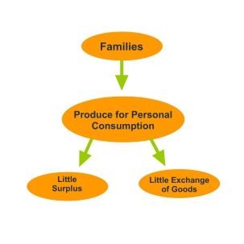
*Types of Economic Systems
*Traditional Economy = (subsistence economy)
people produce most of what they need to survive
(hunting, gathering, farming, herding, make their
own clothing/tools).

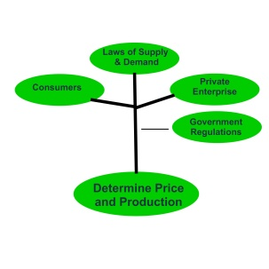
*Market Economy= (free enterprise) is the
buying and selling of goods and
services; gives great freedom to individuals
and groups; capitalism is the primary form
today.
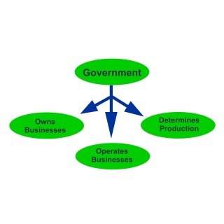

*Command Economy= government controls
what/how goods are produced and what they
cost. Individuals have little economic power.

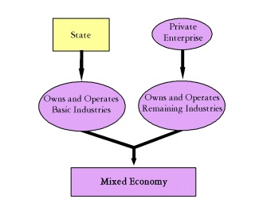
*Mixed Economy = Individuals make some
economic decisions and the government makes
the others.

6. Traditions and Norms
*A Tradition is a belief or behavior passed down within a group or society with symbolic
meaning or special significance with origins in the past.
*A Norm is a group-held belief about how members should behave in a given context or
situation. These are informal understandings that govern society's behaviors and
promote a great deal of social control.
7. Arts and Entertainment
* The products of the human imagination.
*They help us pass on the culture's basic beliefs.
*Art
*Music
*Literature
*Folk Tales
Cultural Hearth=center or birthplace where important ideas begin and from which they spread to
surrounding cultures.
Folk Culture=
*traditional
*typically hard to trace to one origin
*developed over a long period of time
*preserved among aging generations
Popular Culture=
*typically traceable to a specific person or group that arises from advances in technology
Cultural Landscapes=Technology is an important part of culture. As human beings use natural resources
or alter the surface of the earth, they produce unique cultural landscapes that reflect specific
cultures
(Differences illustrated by the different tools and technique used in places like China
and the United States Midwest. Similarities illustrated by the similarities in city skylines
and amenities of modern cities)

Cultural Change=Cultures change by both internal and external influences.
Internal: new discoveries, inventions, technologies.
External: contact with other cultures.

*cultural convergence =occurs when skills, arts, ideas, habits, and institutions of one culture come in contact with another.
*cultural diffusion=the process by which a cultural element is transmitted across distance from
one group or individual to another. This often occurs through migration or through the
exchange of goods and ideas.
*cultural divergence=the restriction of contact with outside cultures in order to limit the spread
of ideas. This occurs when repressive governments seek to control transportation and
communication in and out of an area in order to control the population of the area.

